Instructions for installing DrawCut
- the hottest software on the market!

Thank you for purchasing the cutting software DrawCut LITE / PRO / EXPERT.

The following steps explain how to instsall the upgrade
(in our example we are upgrading from DrawCut LITE to PRO):

- After purchasing your upgrade, wait to receive your invoice via email.
It includes your serial number (= voucher code).

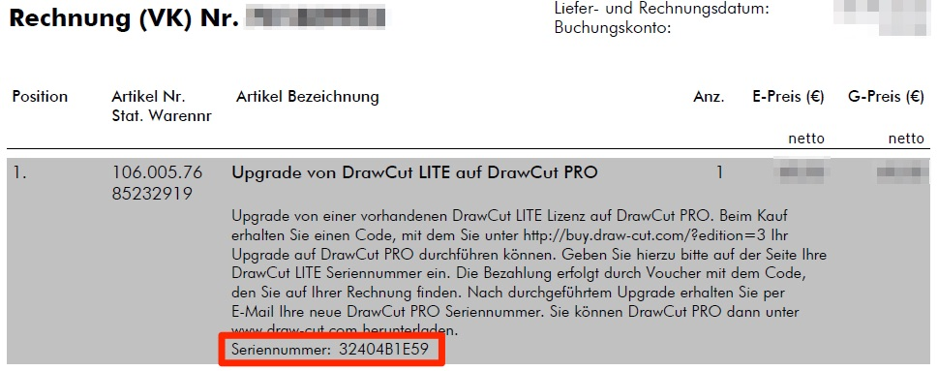
- Next, visit our page at www.draw-cut.com/de. Click on PRICES in the menu bar and select the desired item under UPGRADES.
In our example, we will select DRAWCUT PRO - UPGRADE FROM LITE and click BUY NOW!
- In the next step, all fields need to be filled out. At this point, it is important that you have your DrawCut LITE key handy (you can find view it in the DrawCut LITE software by clicking Help -> About DrawCut -> Product PSN) and enter it in the appropriate field below and continue.
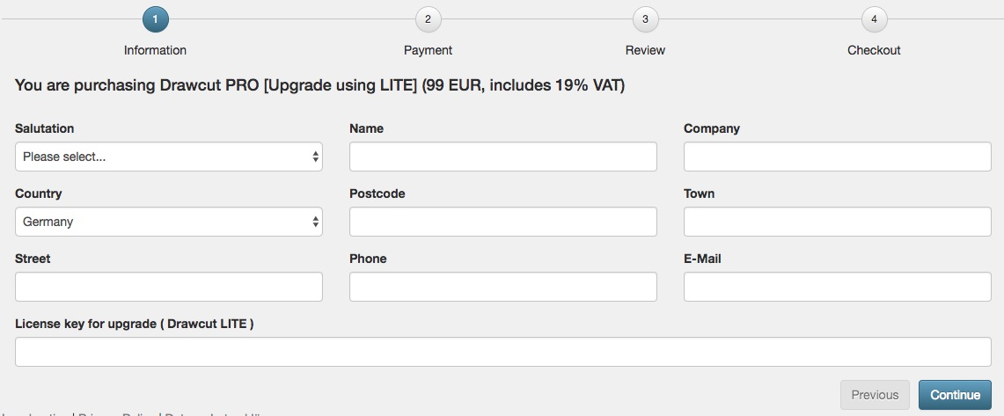
- Next, enter the serial number of your invoice in the Voucher field
(in our example: 32404B1E59) and continue.
- You will now be displayed an overview of all entered data for your review.
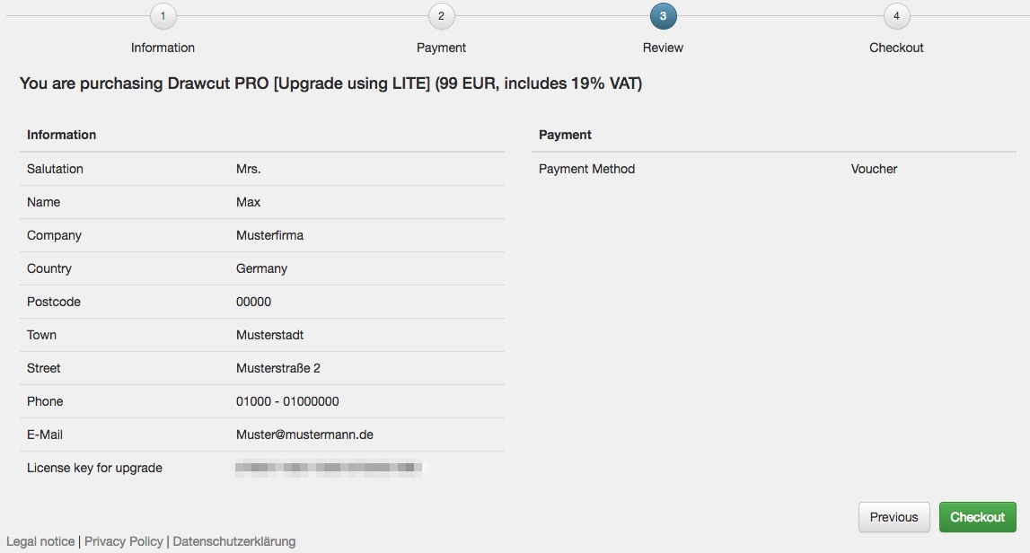
- After pressing Checkout, you will receive a confirmation email with your new serial number (in this case, DrawCut PRO).
- IMPORTANT: Completely uninstall DrawCut LITE, e.g. via "Uninstall a Program" (Windows), so that no folders remain.
- Next, download the full version (in this example DrawCut PRO) from our site www.draw-cut.com/de and install it. During setup you will be asked for the new DrawCut PRO serial number. Complete the setup and you're done!

Tip: You can find many helpful videos about common applications of the cutting software directly on our YouTube Channel: https://www.youtube.com/drawcut

If you have any questions or problems, please contact DrawCut Support at: http://helpdesk.draw-cut.com/support/home.

Thank you and have fun with DrawCut - the hottest software on the market!

Your DrawCut team.

LEGAL NOTICE / IMPRINT
NEPATA Vertrieb GmbH
Hochstatt 6-8
85283 Wolnzach
Germany

